Institute of computer technology

B.Tech-CSE(BDA)

Name:- Shaikh Anik

Sem:-3

Enrollment no.:-23162121021

Batch:-31

Sub:-DBMS

Date:-21/8/2024

Practical 4

Q:- Create tables with various Data Constraints and verify by inserting

values in it.

Scenario : Mohan as an engineer know what are the issues when an entry gets

wrongly inserted. Thus to avoid such issues Mohan suggested to have

constraints so that whenever by mistake also if someone tries to enter data can

first get checked and than inserted.

A) Table Name: Client_master

Description: Used to store information about clients.

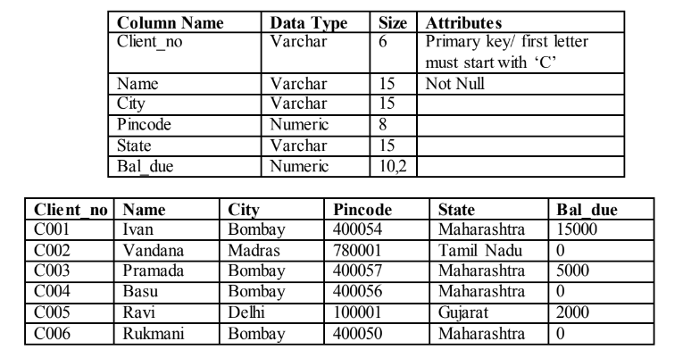

B) Table Name: Product_master

Description: Used to store information about products.

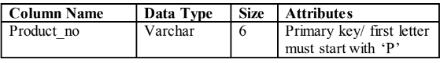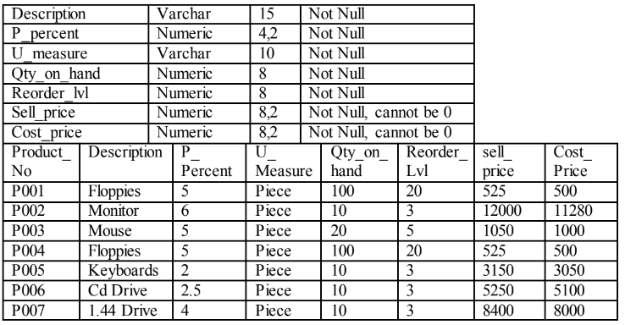

C) Table Name: Salesman_master

Description: Used to store information about salesman working in the company.

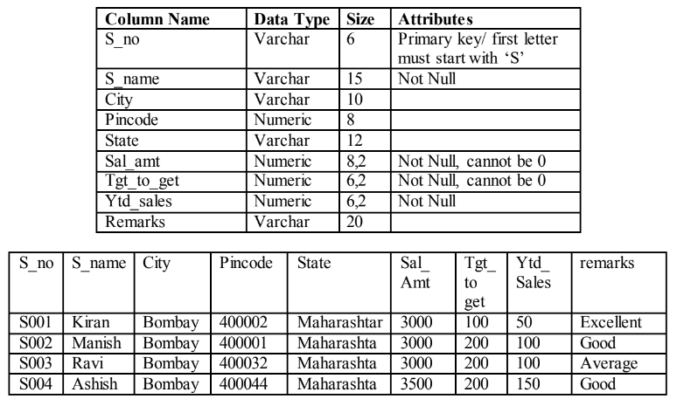

D) Table Name: Sales_order

Description: Used to store client’s orders.

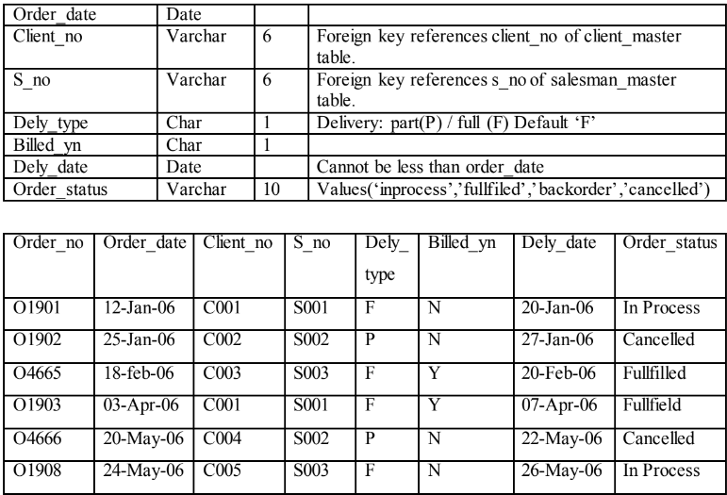

E)Table Name: Sales_order_details

Description: Used to store client’s orders with details of each product ordered.

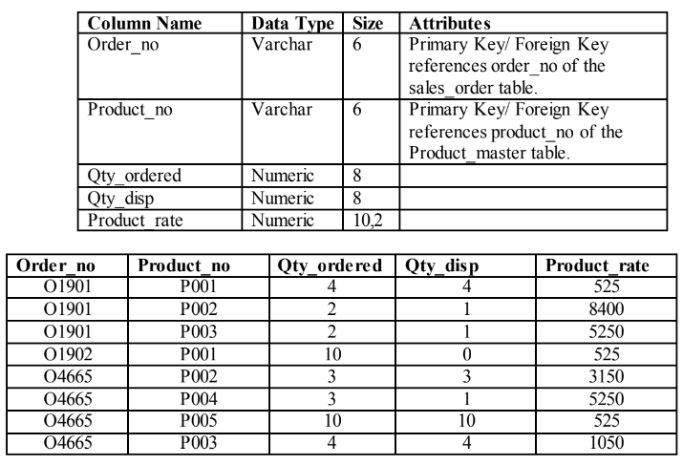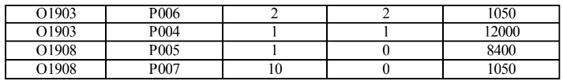

Exercise:Create Above tables with given constraints and insert data in it.

A=> Query:- use bda_23162121021;

create table client_master(Client_no varchar(6) primary key check(Client_no like 'C%'), Name varchar(15) NOT NULL, City varchar(15), Pincode numeric(8), State varchar(15), Bal_due numeric(10,2));

desc client_master;

insert into Client_master values( 'C001', 'Ivan', 'Bombay', 400054, 'Maharastra', 15000);

insert into Client_master values( 'C002', 'Vandana', 'Madras', 780001, 'Tamil Nadu', 0);

insert into Client_master values( 'C003', 'Pramada', 'Bombay', 400057, 'Maharastra', 5000);

insert into Client_master values( 'C004', 'Basu', 'Bombay', 400056, 'Maharastra', 0);

insert into Client_master values( 'C005', 'Ravi', 'Delhi', 100001, 'Gujarat', 2000);

insert into Client_master values( 'C006', 'Rukmani', 'Bombay', 400050, 'Maharastra', 0);

select * from Client_master;

create table product_master(Product_no varchar(6) primary key check(Product_no like 'P%'), Description varchar(15) NOT NULL, P_percent numeric(4,2) NOT NULL,U_measure varchar(10) NOT NULL,Qty_on_hand numeric(8) NOT NULL,Reorder_lvl numeric(8) NOT NULL,Sell_price numeric(8,2) NOT NULL check(Sell_price not like 0) ,Cost_price numeric(8,2) NOT NULL check(Cost_price not like 0));

desc product_master;

insert into Product_master values( 'P001', 'Floppies', 5, 'Piece', 100, 20, 525, 500);

insert into Product_master values( 'P002', 'Monitor', 6, 'Piece', 10, 3, 12000, 11280);

insert into Product_master values( 'P003', 'Mouse', 5, 'Piece', 20, 5, 1050, 1000);

insert into Product_master values( 'P004', 'Floppies', 5, 'Piece', 100, 20, 525, 500);

insert into Product_master values( 'P005', 'Keyboards', 2, 'Piece', 10, 3, 3150, 3050);

insert into Product_master values( 'P006', 'Cd Drive', 2.5, 'Piece', 10, 3, 5250, 5100);

insert into Product_master values( 'P007', '1.44 Drive', 4, 'Piece', 10, 3, 8400, 8000);

select * from Product_master;

create table salesman_master(S_no varchar(6) primary key check(S_no like 'S%'),S_name varchar(15) NOT NULL,City varchar(15), Pincode numeric(8), State varchar(15),Sal_amt numeric(8,2) NOT NULL check(Sal_amt not like 0) ,Tgt_to_get numeric(6,2) NOT NULL check(Tgt_to_get not like 0),Ytd_sales numeric(6,2) NOT NULL,Remarks varchar(20));

desc salesman_master;

insert into Salesman_master values('S001', 'Kiran', 'Bombay', 400002, 'Maharastra', 3000, 100, 50, 'Excellent');

insert into Salesman_master values('S002', 'Manish', 'Bombay', 400001, 'Maharastra', 3000, 200, 100, 'Good');

insert into Salesman_master values('S003', 'Ravi', 'Bombay', 400032, 'Maharastra', 3000, 200, 100, 'Average');

insert into Salesman_master values('S004', 'Ashish', 'Bombay', 400044, 'Maharastra', 3500, 200, 150, 'Good');

select * from Salesman_master;

create table sales_order(Order_no varchar(6) primary key check(Order_no like 'O%'), Order_date Date, Client_no Varchar(6) ,foreign key(Client_no) references client_master(Client_no), S_no varchar(6) ,foreign key(S_no) references salesman_master(S_no), Dely_Type char(1) DEFAULT 'F' check(dely_type like 'P' or dely_type like 'F'), Billed_yn char(1), Dely_date date ,check(Dely_date >= Order_date), Order_status varchar(10) check(Order_status like 'inprocess' or Order_status like 'cancelled' or Order_status like 'backorder' or Order_status like 'fulfilled') );

desc sales_order;

insert into Sales_order values('O1901' ,str_to_date('02/06/2015', '%d/%m/%Y') ,'C001' ,'S001' ,'F' ,'N' ,str_to_date('20/06/2015', '%d/%m/%Y') ,'InProcess');

insert into Sales_order values('O1902' ,str_to_date('25/01/2015', '%d/%m/%Y') ,'C002' ,'S002' ,'P' ,'N' ,str_to_date('27/06/2015', '%d/%m/%Y') ,'Cancelled');

insert into Sales_order values('O4665' ,str_to_date('18/02/2015', '%d/%m/%Y') ,'C003' ,'S003' ,'F' ,'Y' ,str_to_date('20/02/2015', '%d/%m/%Y') ,'fulfilled');

insert into Sales_order values('O1903' ,str_to_date('03/04/2015', '%d/%m/%Y') ,'C001' ,'S001' ,'F' ,'Y' ,str_to_date('07/04/2015', '%d/%m/%Y') ,'fulfilled');

insert into Sales_order values('O4666' ,str_to_date('20/05/2015', '%d/%m/%Y') ,'C004' ,'S002' ,'P' ,'N' ,str_to_date('22/05/2015', '%d/%m/%Y') ,'Cancelled');

insert into Sales_order values('O1908' ,str_to_date('24/05/2015', '%d/%m/%Y') ,'C005' ,'S003' ,'F' ,'N' ,str_to_date('26/05/2015', '%d/%m/%Y') ,'InProcess');

select * from Sales_order;

create table sales_order_details(Order_no varchar(6), foreign key(Order_no) references sales_order(Order_no), Product_no varchar(6) , foreign key(Product_no) references product_master(Product_no) ,Qty_orderd numeric(8) ,Qty_disp numeric(8) ,Product_rate numeric(10,2));

desc sales_order_details;

insert into sales_order_details values('O1901','P001', 4, 4, 525);

insert into sales_order_details values('O1901','P002', 2, 1, 8400);

insert into sales_order_details values('O1901','P003', 2, 1, 5250);

insert into sales_order_details values('O1902','P001', 10, 0, 525);

insert into sales_order_details values('O4665','P002', 3, 3, 3150);

insert into sales_order_details values('O4665','P004', 3, 1, 5250);

insert into sales_order_details values('O4665','P005', 10, 10, 525);

insert into sales_order_details values('O4665','P003', 4, 4, 1050);

insert into sales_order_details values('O1903','P006', 2, 2, 1050);

insert into sales_order_details values('O1903','P004', 1, 1, 12000);

insert into sales_order_details values('O1908','P005', 1, 0, 8400);

insert into sales_order_details values('O1908','P007', 10, 0, 1050);

select * from sales_order_details;

Screenshots:- 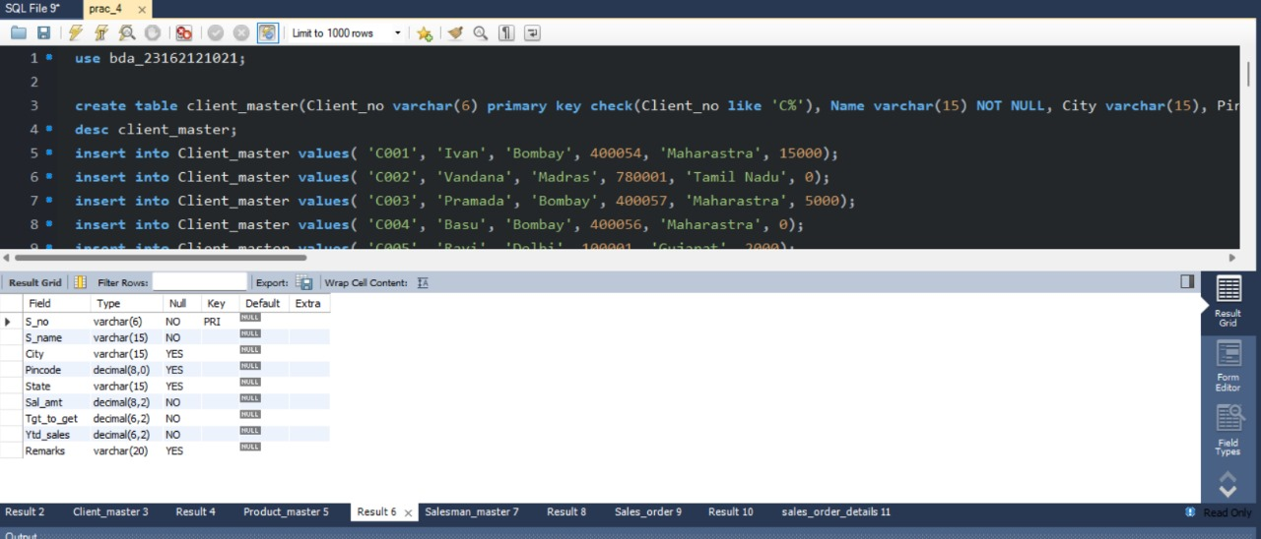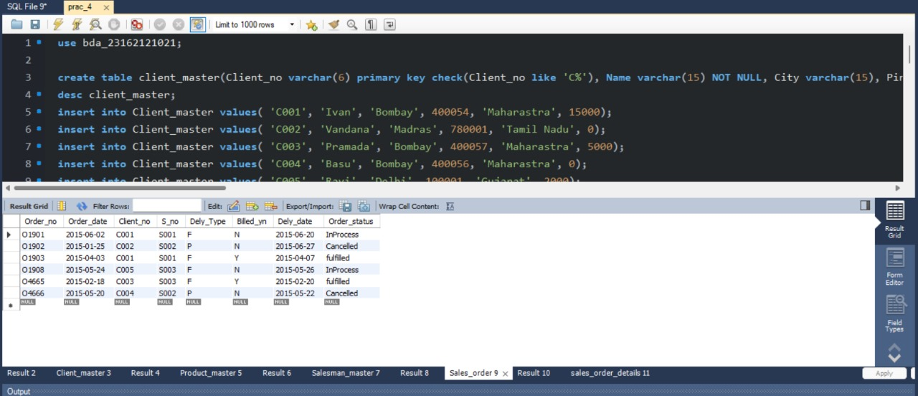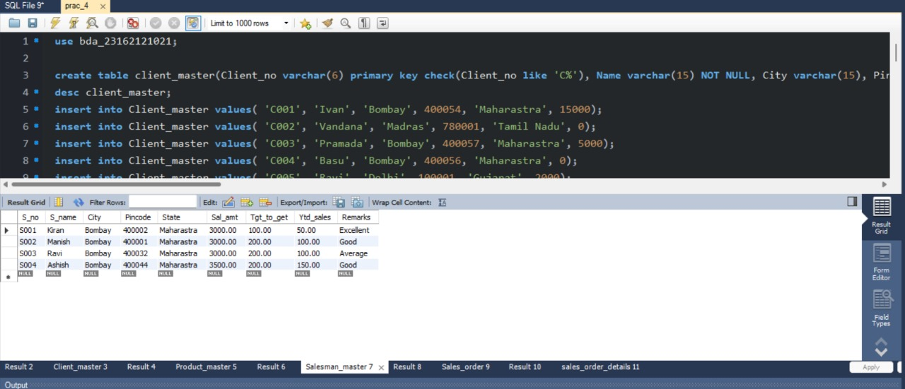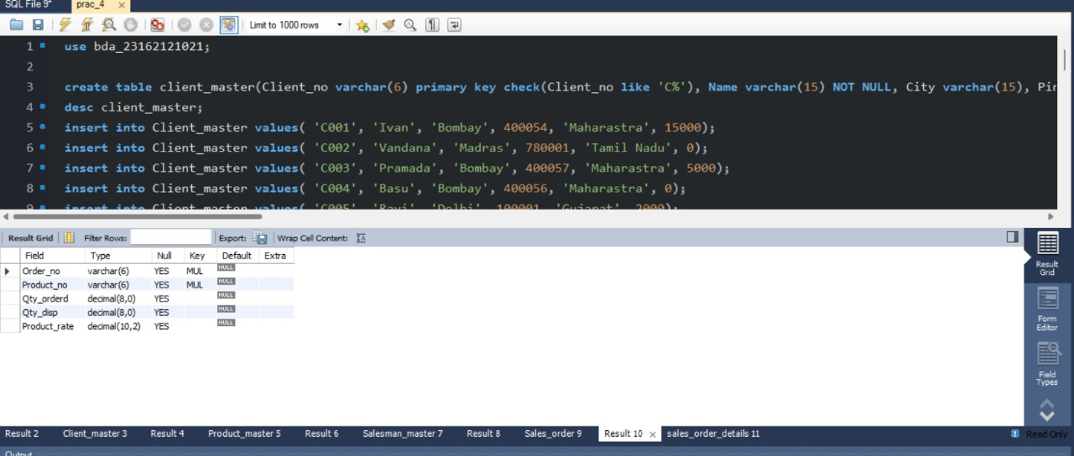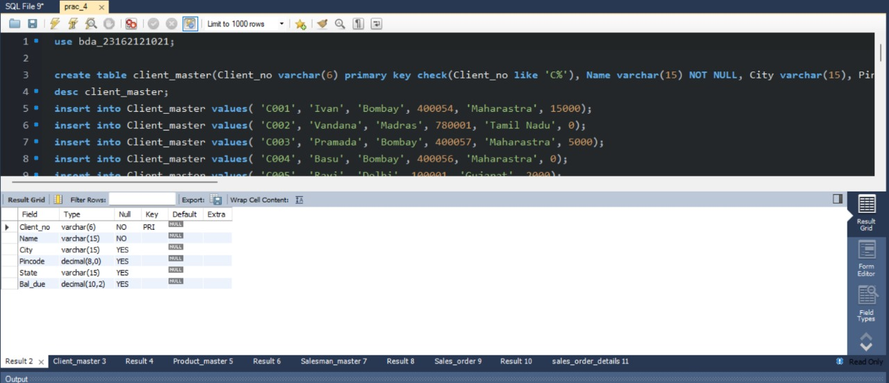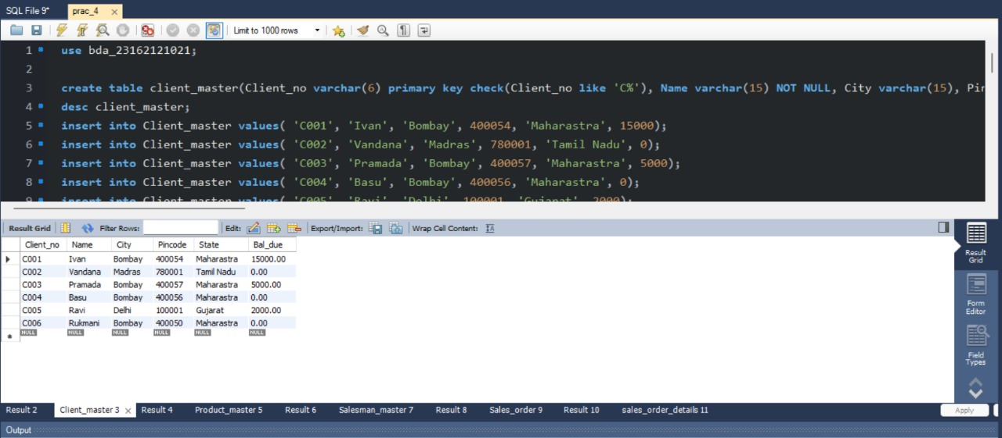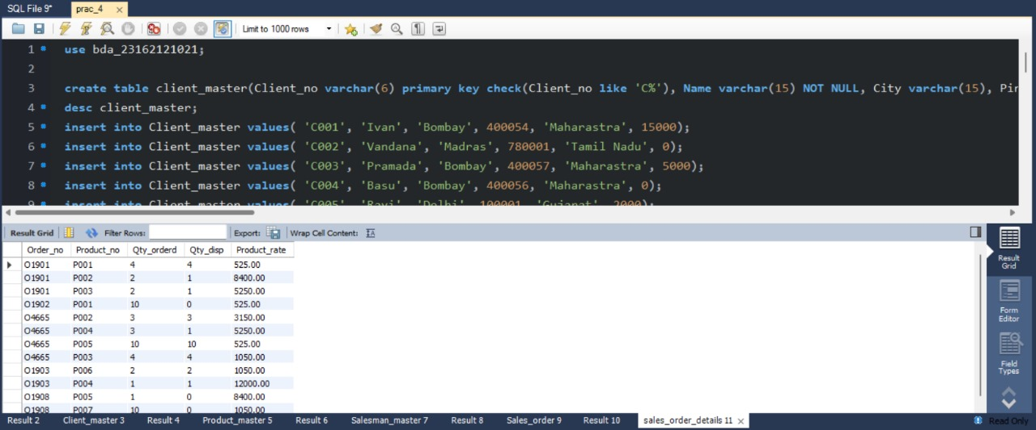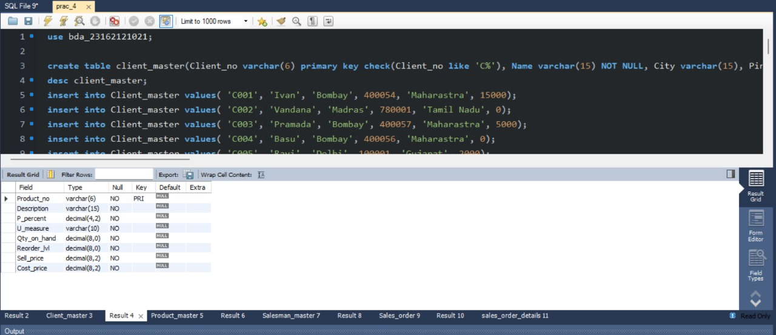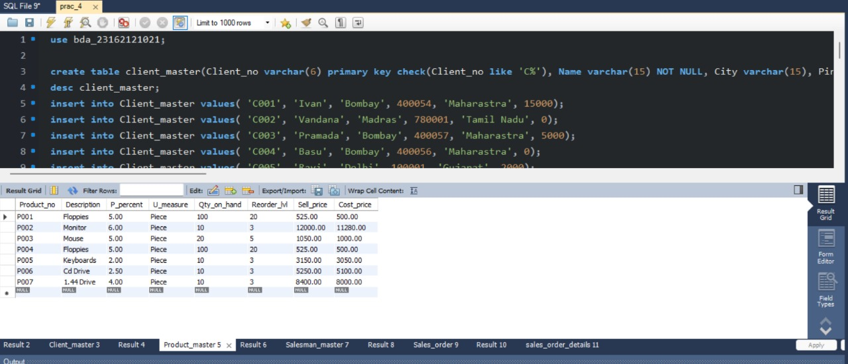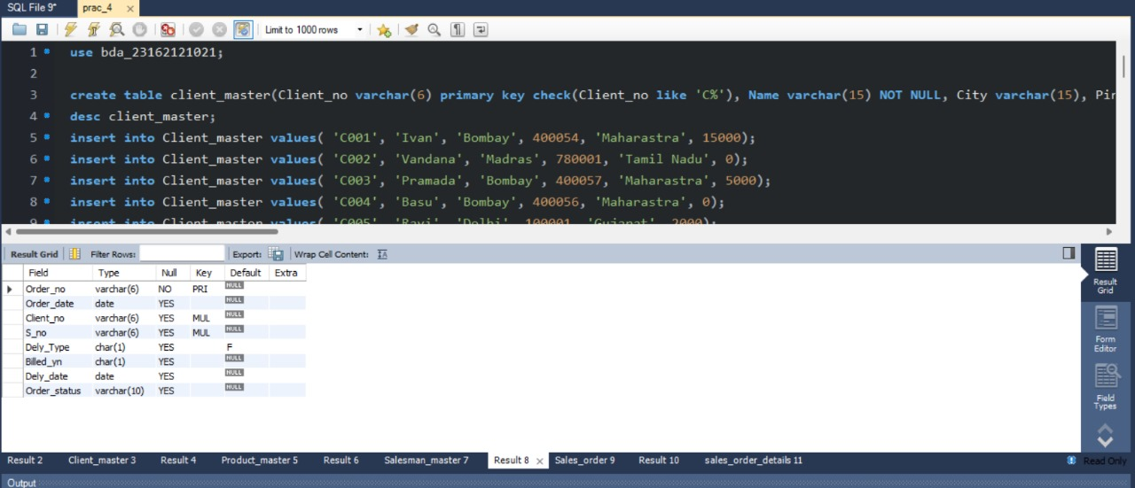

Action logs:- 